Press Release
18 June 2024

Matsuri Japanese Culture Picnic 2024 Coming Up This Weekend!
This Saturday, 22 June, the Matsuri Japanese Culture Picnic will be held on the grounds of the Służew Cultural Centre. This unique event is an excellent opportunity to explore both the traditions of Japan as well as the contemporary aspects of its culture. Guests will enjoy a range of attractions provided by the organisers and partners, including a large-scale Jenga game prepared by the Japanese construction company, Kajima Poland.
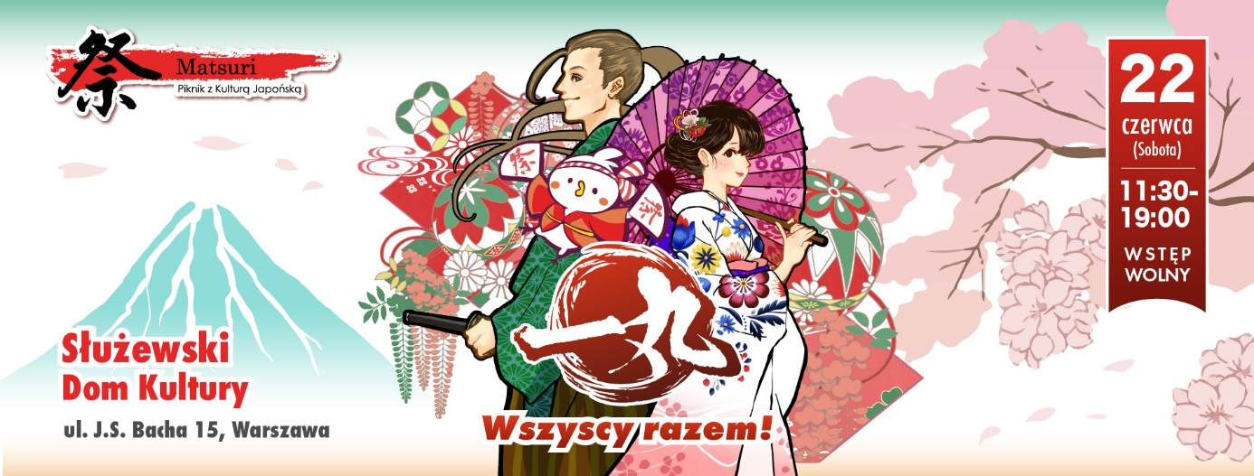
The Matsuri Japanese Culture Picnic 2024 will take place on June 22 at the Służew Cultural Centre, ul. J.S. Bacha 15, Warsaw. This free-admission event, organised since 2013 by the Embassy of Japan in Poland, the SHOKOKAI Employers' Association, and the Japan Club in Poland with support from partners and sponsors, has generated significant interest and overwhelmingly positive responses for over a decade. Visitors can look forward to attractions related to both ancient and modern Japan, including stage performances by Japanese and Polish artists, martial arts demonstrations, cultural workshops, and various food and trade stalls.
Kajima Poland, a general contracting company of Japanese origin, has also prepared attractions for this year’s event. At its booth number F11, visitors will be able to participate in three stands of a large-scale version of Jenga, a popular and enjoyable game designed for all ages. Additionally, guests will receive small company gadgets and participation prizes. Kajima Poland employees present on site will be available to discuss the company and its activities.
"We have been engaged in the Matsuri Japanese Culture Picnic since 2014. Our involvement in this event stems from the Japanese DNA of the Kajima brand the desire to emphasize its Japanese roots. We also aim to support and deepen the relationship between Poland and Japan through cultural exchange. We have witnessed the growing popularity of the event each year. This is an important platform for us to reach out to Japanese culture enthusiasts as well as those simply seeking an enjoyable leisure activity. Our games and activities at the booths have been particularly popular, especially among the youngest visitors. We warmly welcome everyone to join us," says Sandra Wróblewska, Senior Business Development Manager at Kajima Poland.

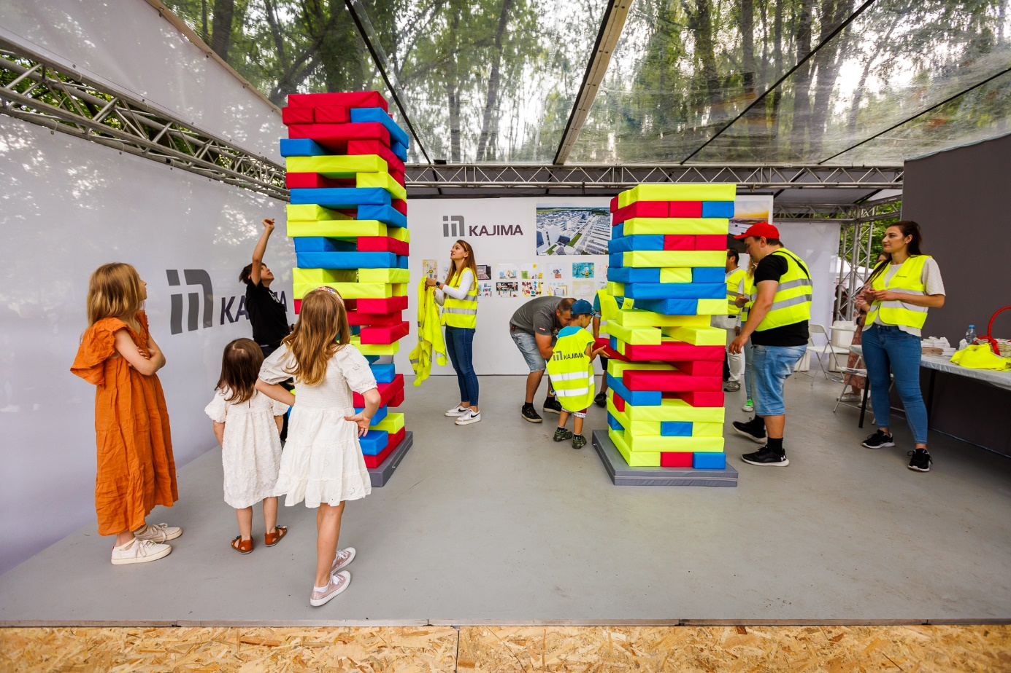
The Matsuri Japanese Culture Picnic 2024 will be held on 22 June from 11:30 a.m. to 7 p.m. Admission is free.

***

Kajima Poland Sp. z o.o. is part of the global construction firm, Kajima Corporation. The company is wholly owned by Kajima Europe Design and Construction (Holding) Limited, headquartered in the United Kingdom. Specialising in general contracting services, Kajima Poland excels in constructing industrial, logistics, retail, office, and residential buildings, leveraging the latest advancements in design and construction technologies. Since the beginning of its presence in Poland, the company has successfully delivered over 150 projects, ranging in size from 10,000 to 200,000 sqm. For 2023, the company reported revenue totalling PLN 847 million, with a net profit of PLN 58.3 million.

The company’s portfolio includes projects completed for 3M Wrocław, 7R, Ajinomoto Poland, Aries Motor Poland, Arvato Polska, Bridgestone Poland, CTP Invest, Electrolux Poland, EQT Exeter, Frigo Logistics, Gates Polska, Haerter Technika Wytłaczania, Hillwood Polska, Hines, IKEA Centres Polska S.A. (currently Ingka Centres), IKEA Property Poland, Johnson Controls Siemianowice, Kosmepol (L’Oreal), LemonTree, Mercedes-Benz Poland, Mitsui Motor Poland (currently Yamaha Motor Poland), Mondelez Poland, Nestlé Purina, NGK Ceramics Poland, Nutricia Zakłady Produkcyjne, OPONEO.PL S.A., P3 Logistic Parks, Panattoni, Parker Hannifin, Peakside Capital Advisors, Prologis Poland, Robert Bosch, Saint-Gobain Sekurit HanGlas Poland, Sanden Manufacturing Poland, SATO Poland, Sony Poland, Student Depot, Tetra Pak, Toyota Europe Engineering & Maintenance, Toyota Tsusho Europe, and UOS Drilling S.A.
In addition to its general contracting services, Kajima Poland also provides design services, including Building Information Modelling (BIM), and prepares facilities for BREEAM, LEED, and WELL certification. Kajima Poland is recognised for its proficiency in managing tight construction schedules and executing expansions of operational facilities without disruption to ongoing production or logistics operations. The company holds ISO14001 certification, has achieved a silver medal for sustainability on the EcoVadis platform, and operates as a participant of the United Nations Global Compact (UNGC).
Upholding Japanese organisational principles and a strong commitment to social responsibility, Kajima Poland fosters enduring and mutually beneficial relationships with all its business partners, grounded in mutual respect and shared interests. Within Europe, Kajima also offers general contracting services in the Czech market as Kajima Czech Design and Construction, and in Germany as Kajima Deutschland.
For more information, visit www.Kajima.pl

Contact:
Mariusz Skowronek | mskowronek@tauber.com.pl | + 48 698 612 866

